Online Balloting in DerbyNet
In addition to the various speed awards for a pinewood derby event, many organizations offer design and workmanship awards: “Most Patriotic,” “Coolest Car,” “Best in Show,” etc. Typically the recipients of these awards are chosen by one or a small panel of judges. However, an alternative worth considering is to allow the audience or the race participants to vote on who should win some or all of these awards. DerbyNet offers support for online balloting, by which users who can connect to the DerbyNet server are able to cast their votes on various awards.
If you use online balloting, it is strongly encouraged that you have car photos for all or more of the cars in your race. Otherwise, voters must make selections on the basis of the car number only, a vastly less rewarding experience.
- Online balloting starts by having a logged-in user visit the Judging page, and click on the “Manage Ballot” button. | 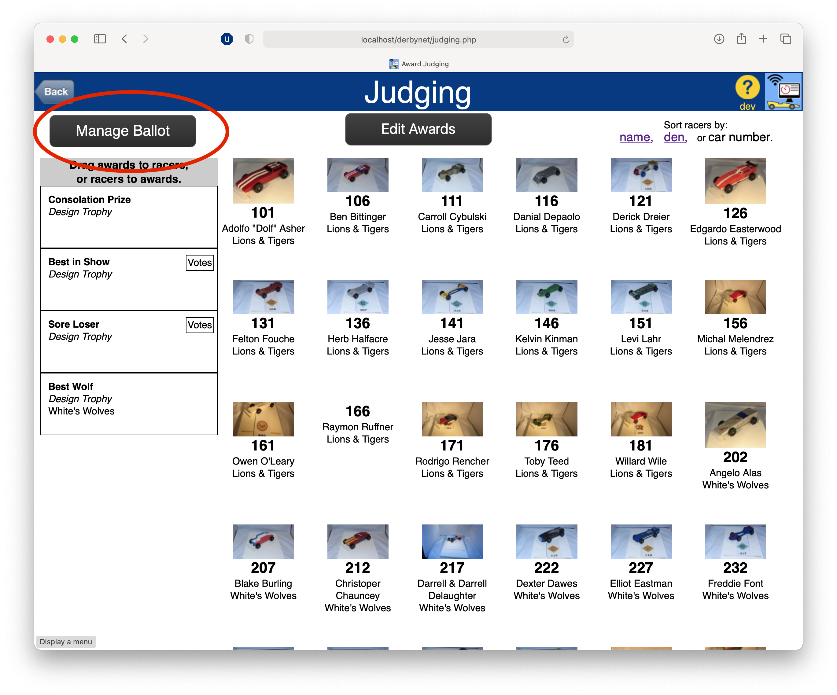
- In the dialog that appears, mark those awards for which you wish to solicit votes. For each such award, decide how many votes each person may cast for that award. (Bear in mind that young racers are likely to be tempted to vote for themselves. One strategy for dealing with that is to allow them to vote for multiple distinct candidates: they might waste one vote on their own car, but their remaining votes would identify truly deserving recipients.) | 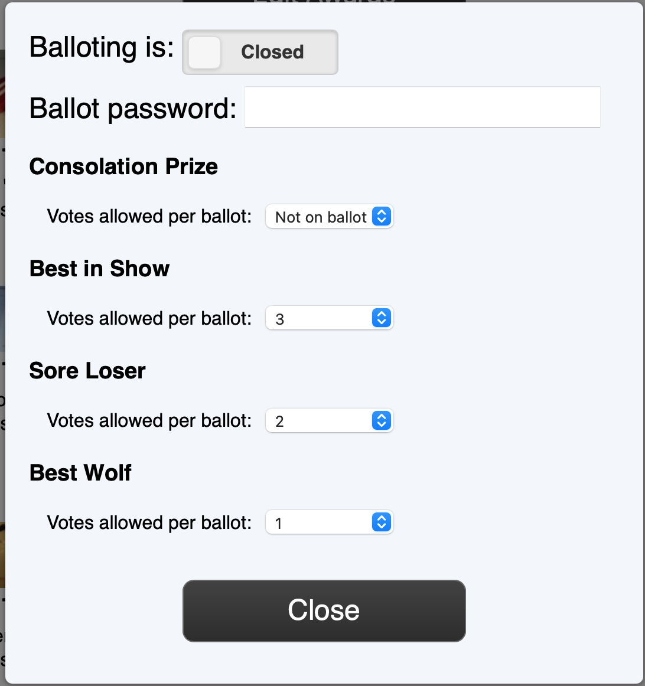
- If you wish, you can set a password, to try to limit voting to authorized users. (For online balloting in combination with live streaming, consider announcing or presenting the password in the live stream.)
- No votes can be cast unless or until balloting is open. The control at the top of the dialog lets you choose when voting is allowed.
- When at least one award has been selected for balloting, users who are not logged in are offered a “Vote!” choice on the landing page. | 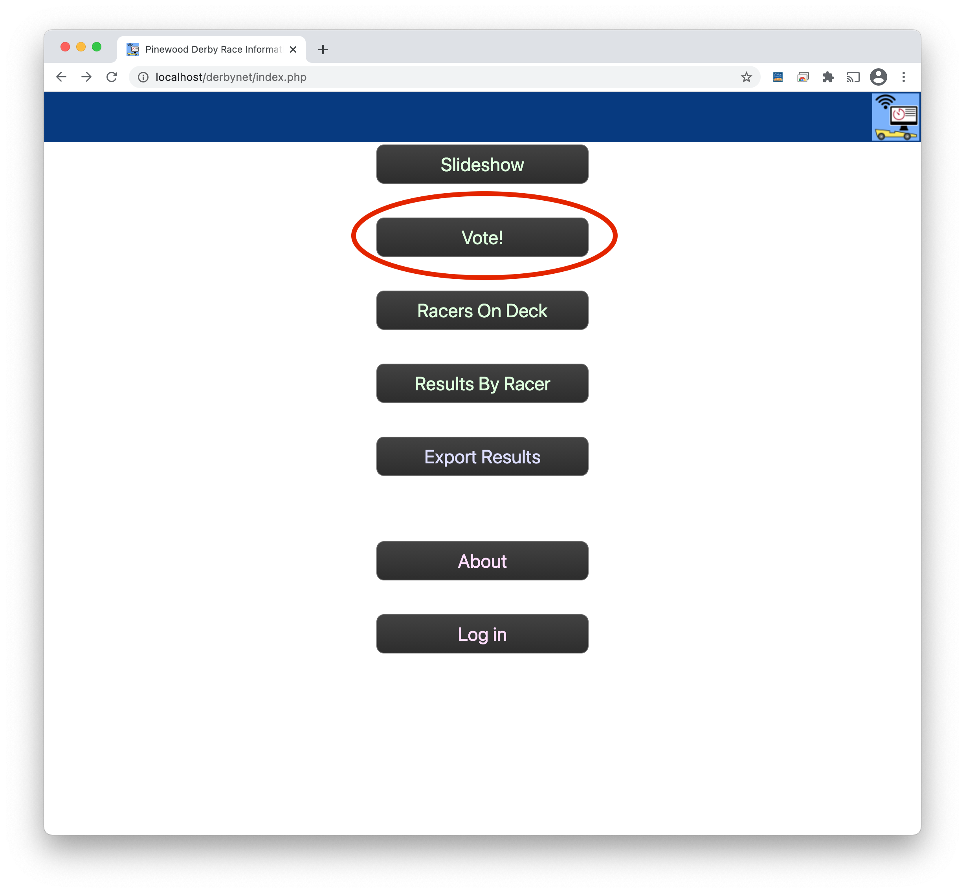
- If balloting is open, the voting page shows a list of the awards available for voting, and the voter’s current selections, if any. (Visitors who have already voted from the same browser may change their votes as long as balloting remains open, but they are not able to cast new ballots.) | 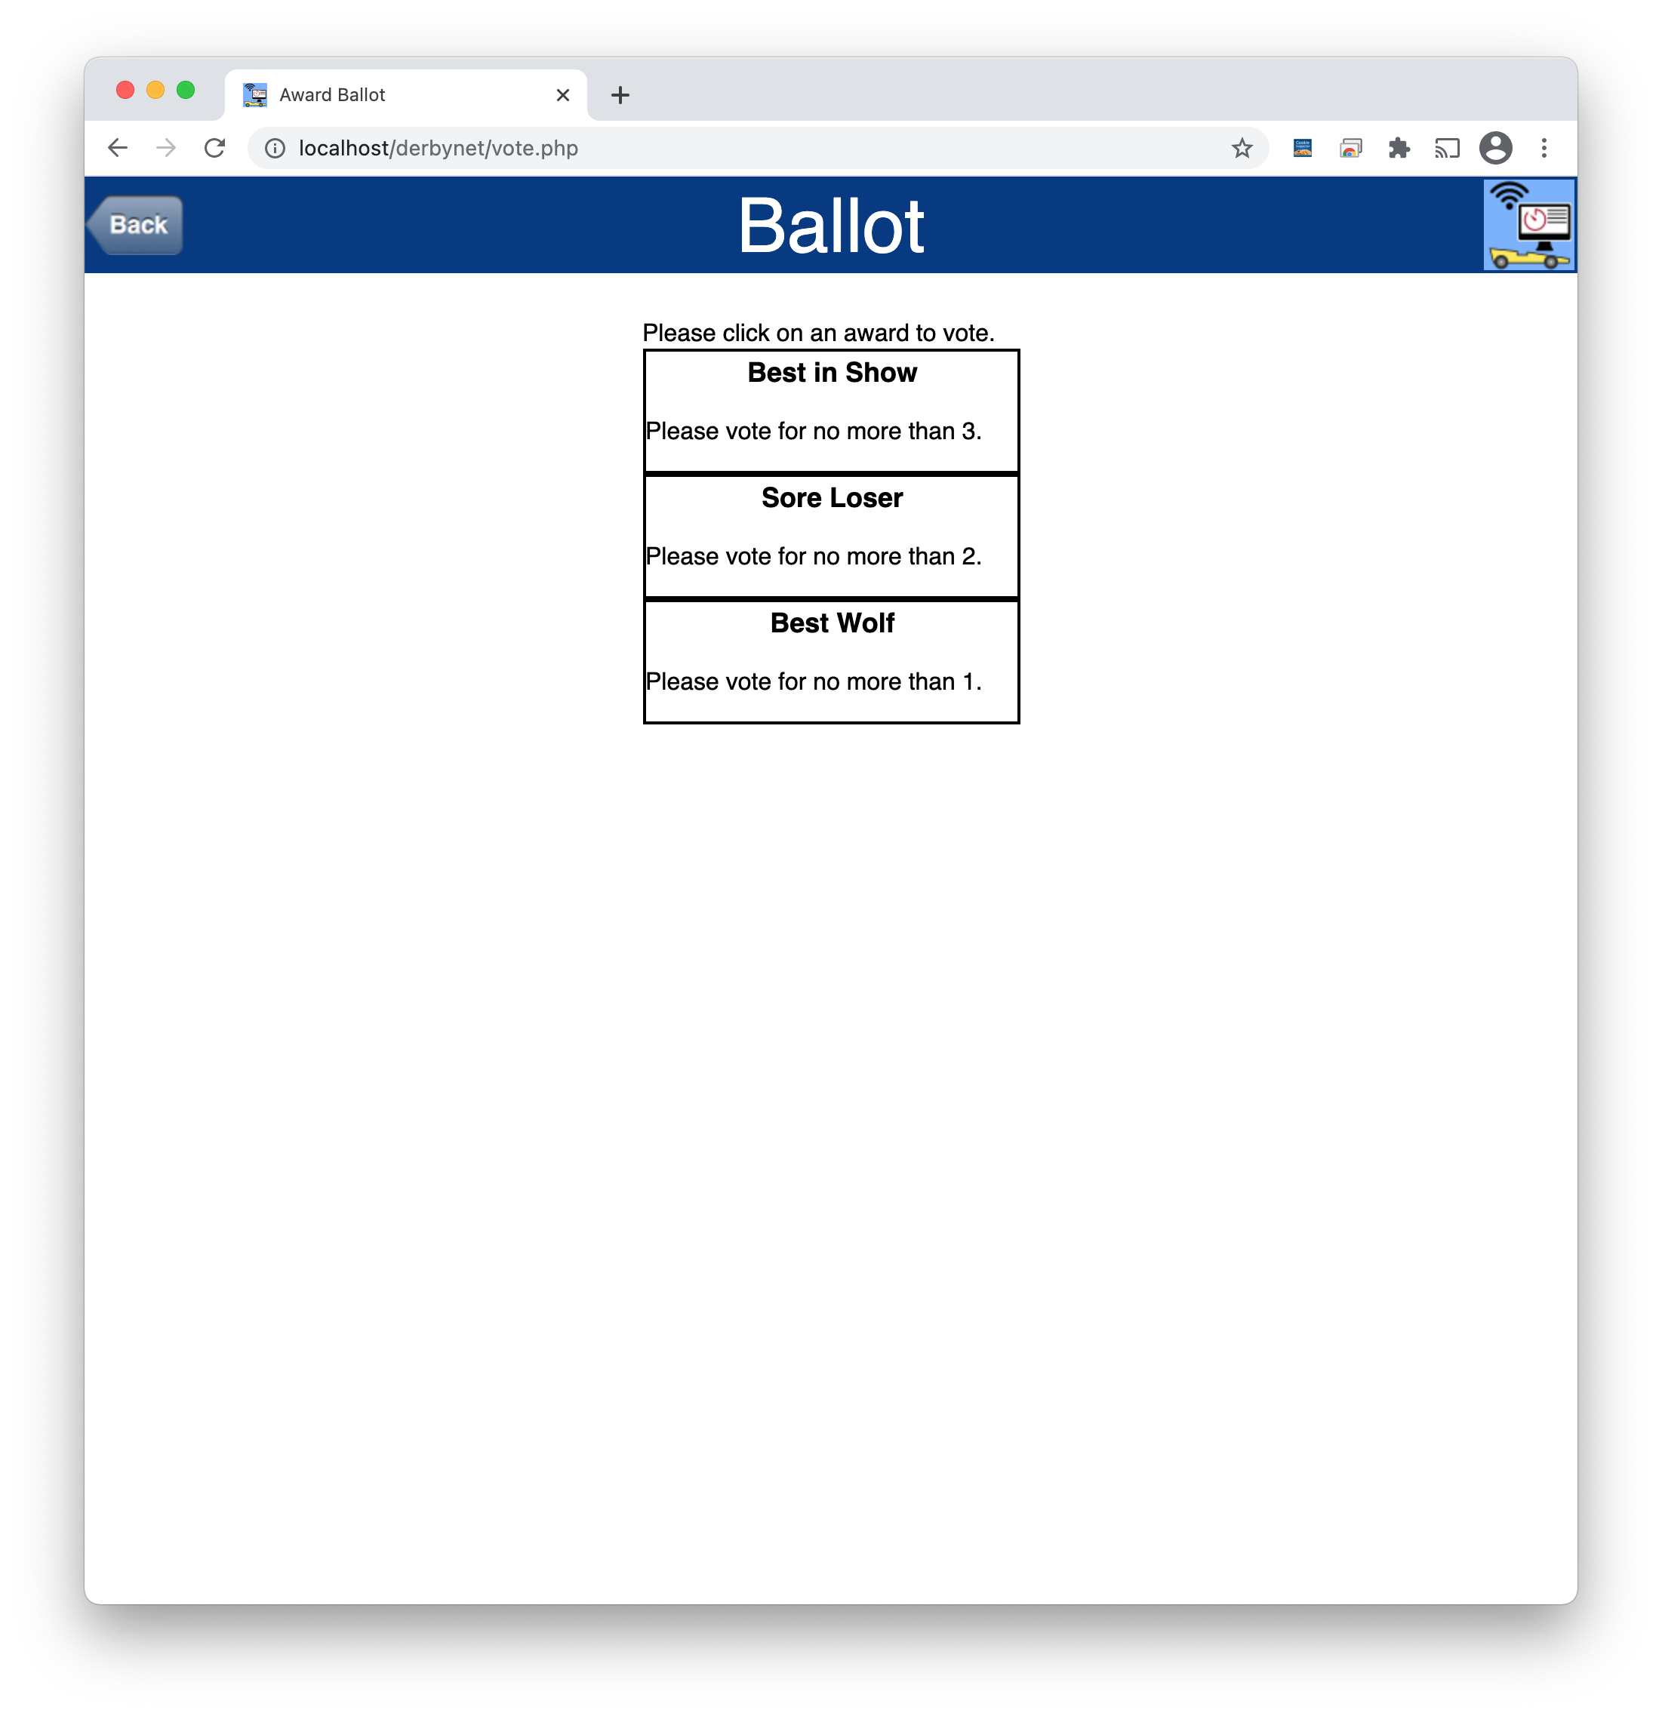
- Clicking on an award shows the field of eligible candidates for that award. | 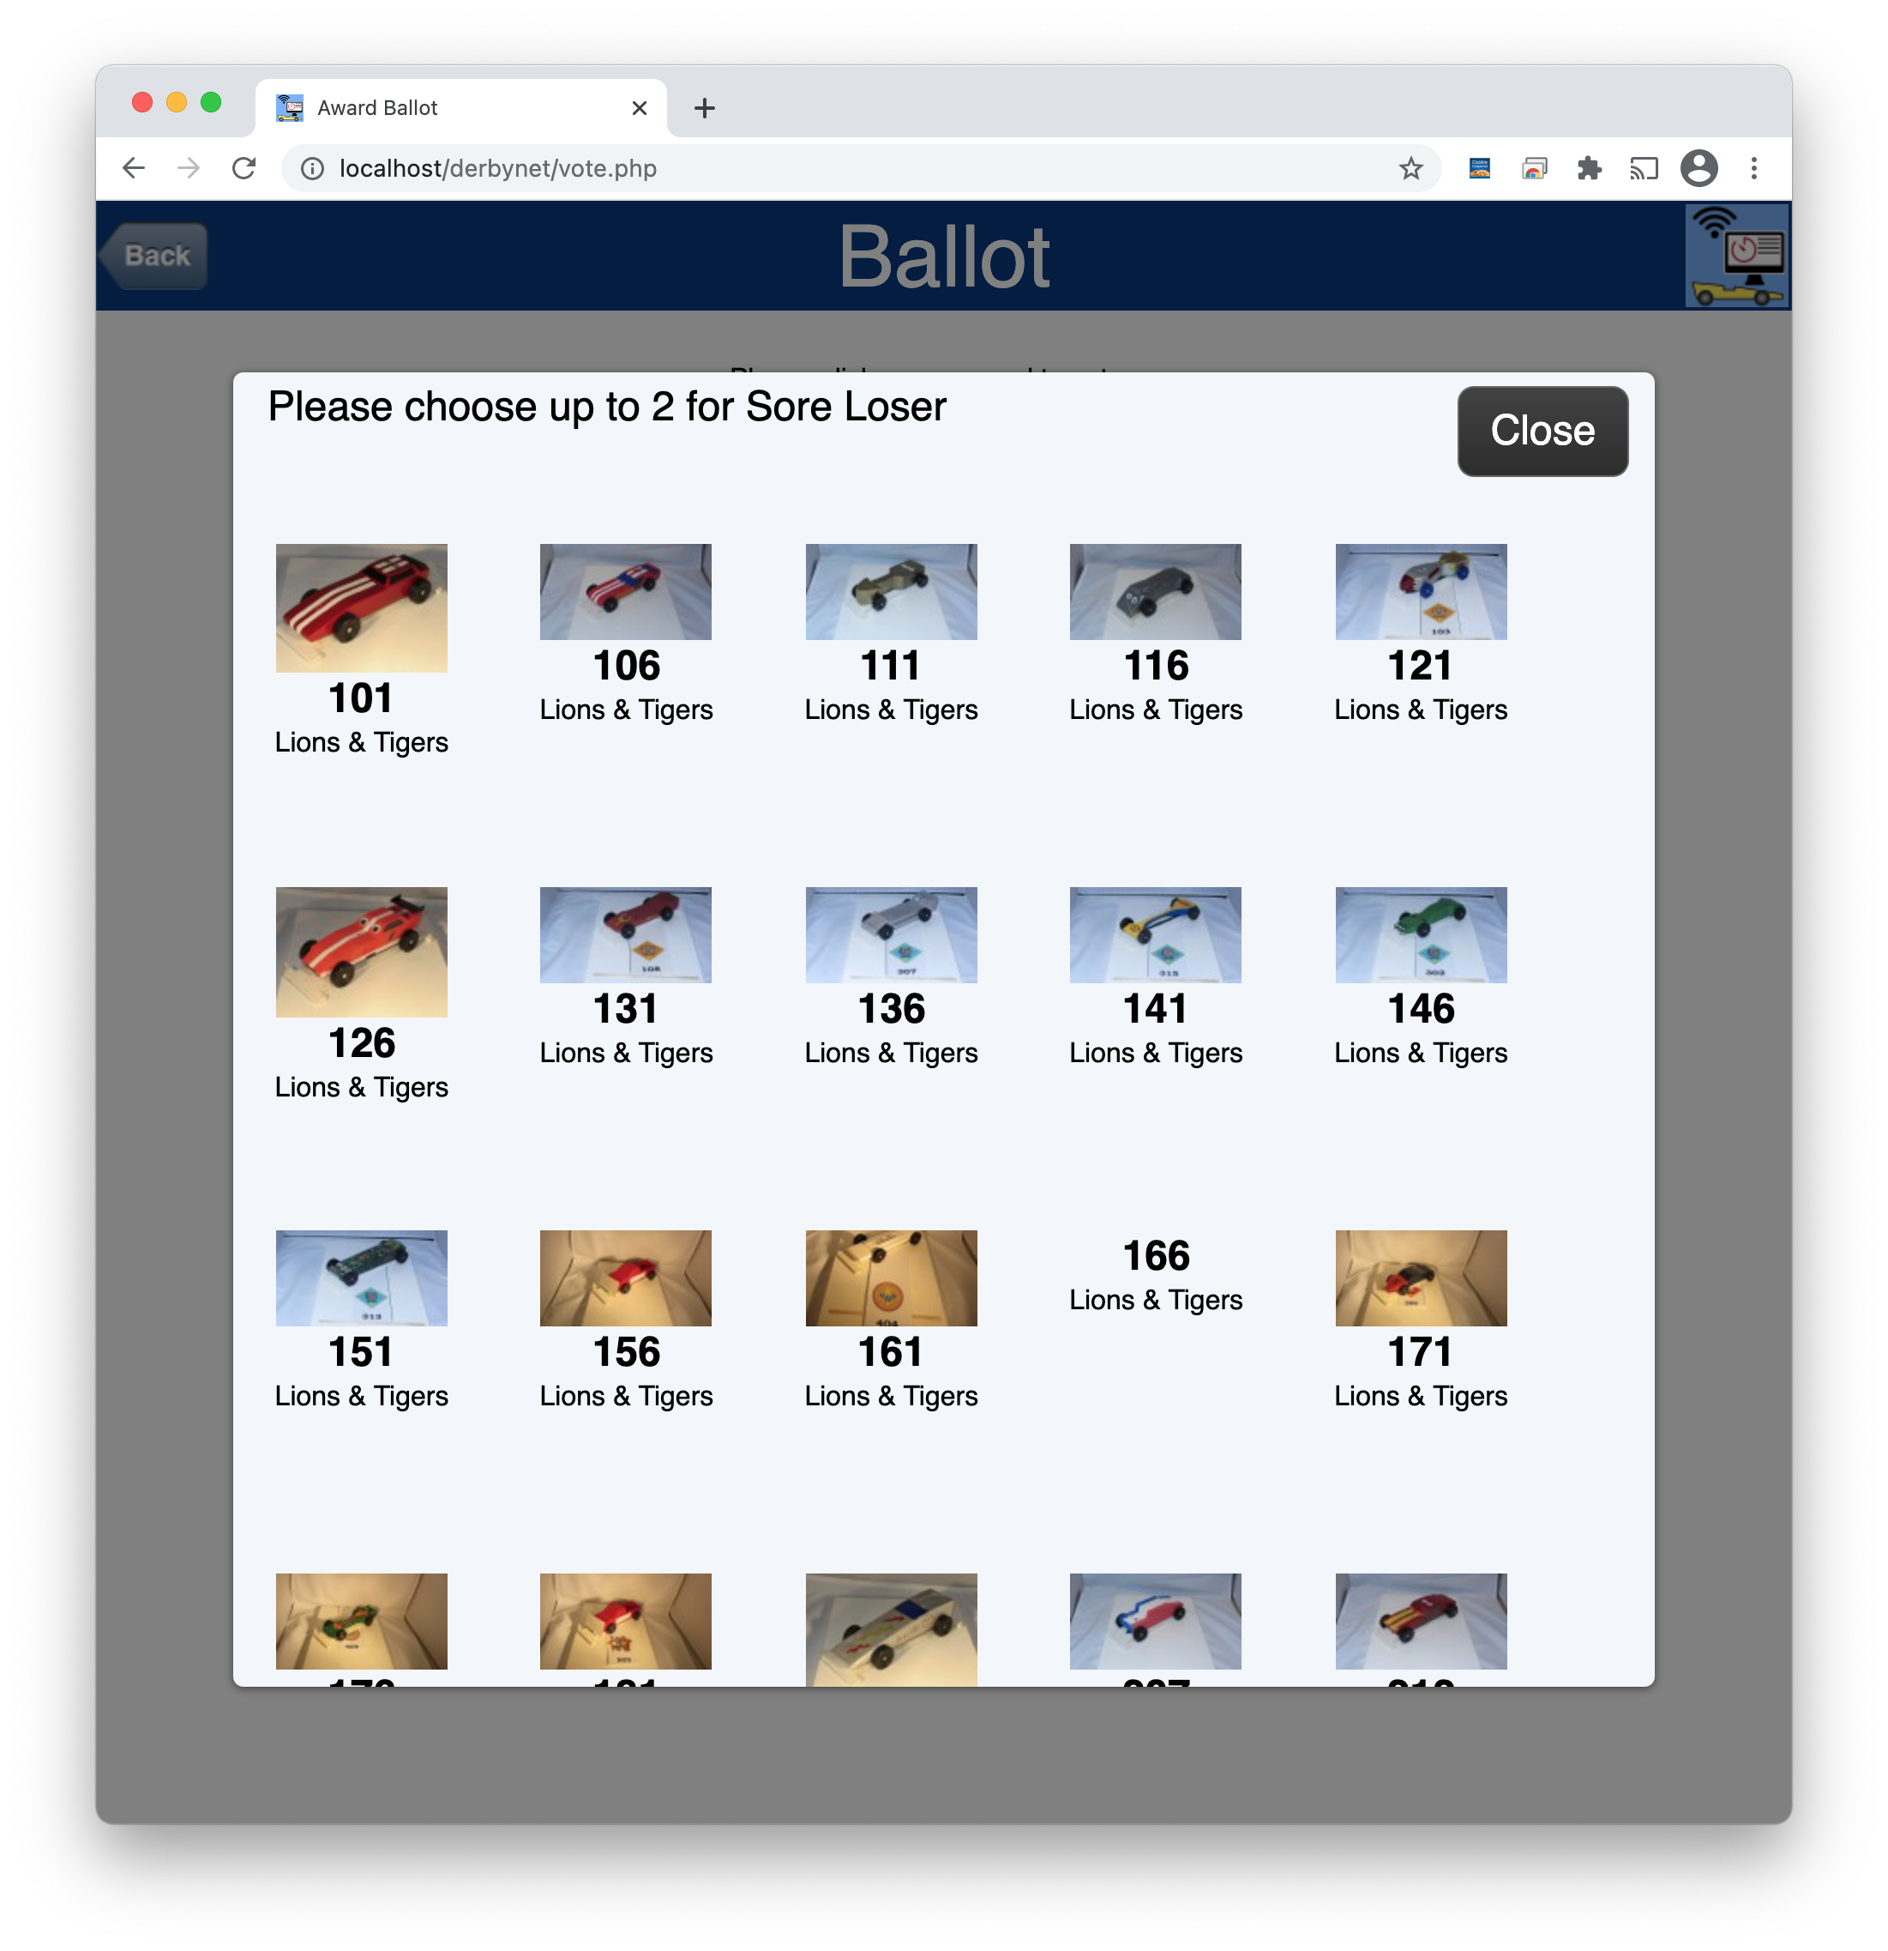
- Clicking on a candidate lets the voter see a full-size photo of the car. Clicking in the “Vote” box selects or de-selects the candidate. | 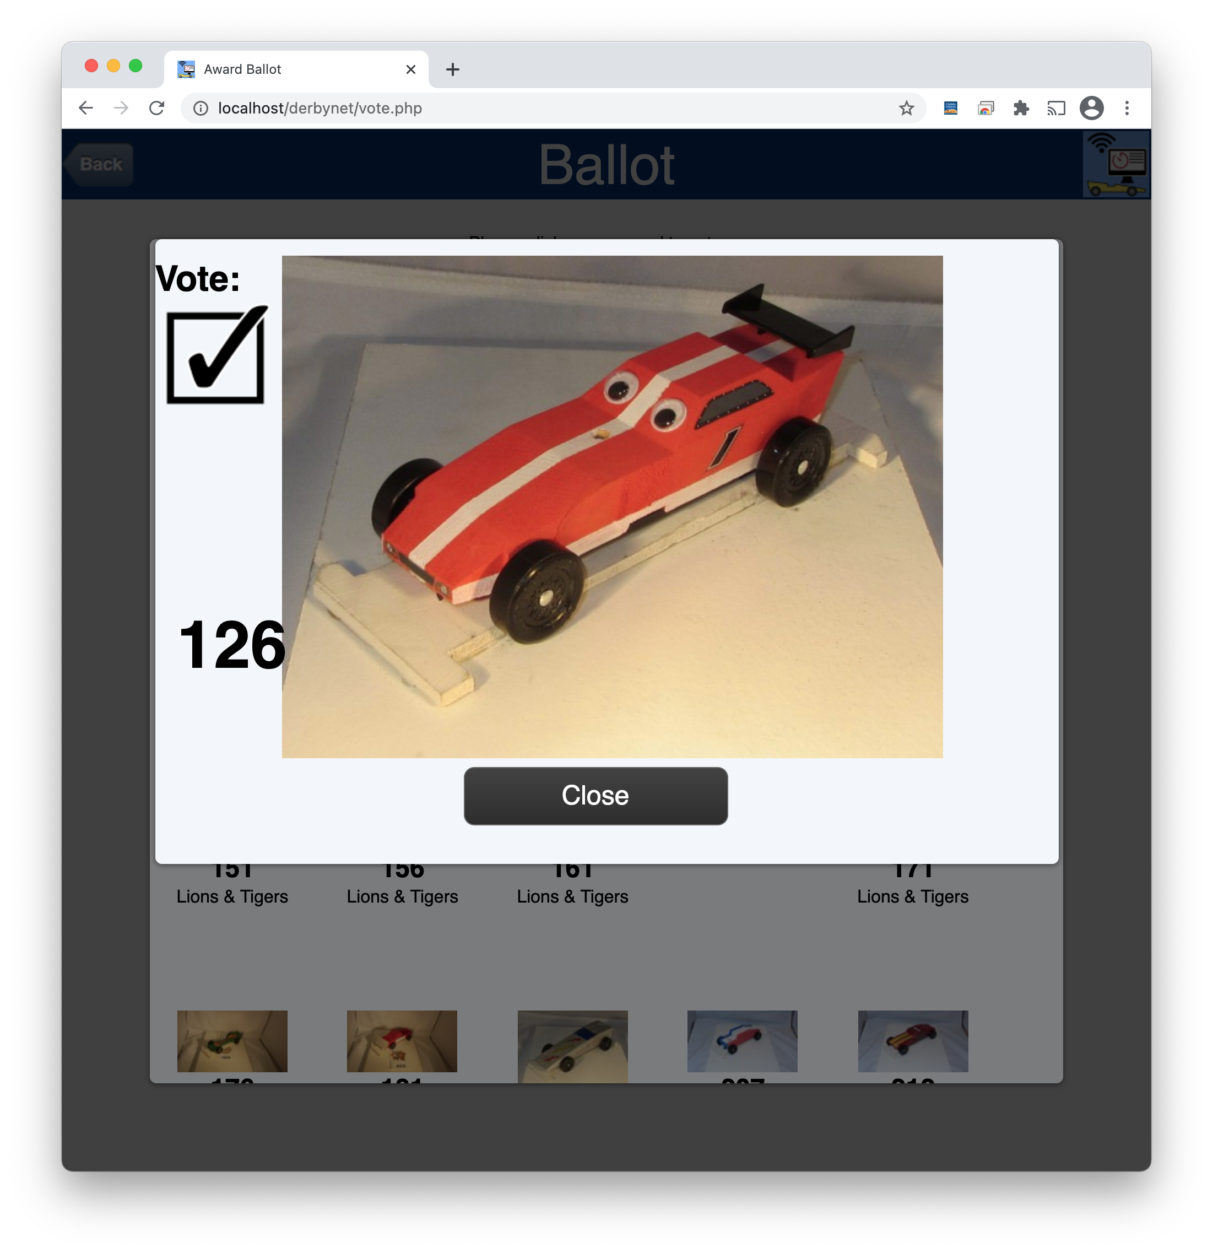
- On the Judging page (for logged-in users), when at least one vote has been received for an award, a “Votes” marker appears on the award. | 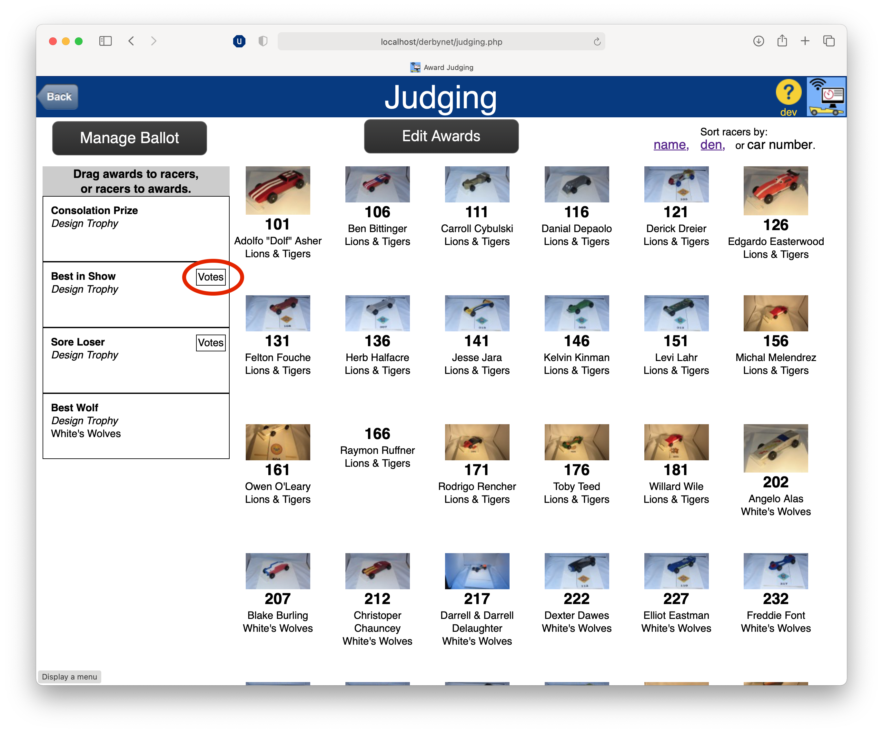
- Clicking on the “Votes” marker opens a dialog showing the vote tabulations for the award.  Each entry in the tabulation has a “Choose” button. Clicking on a “Choose” button will assign that candidate as the winner of the award.  You, the judge, retain final authority to choose who wins the award, regardless of the votes cast. (At the least, you’ll want to be able to resolve tie votes.)  All awards can still be assigned or unassigned by dragging and dropping, whether or not they’re on the online ballot. | 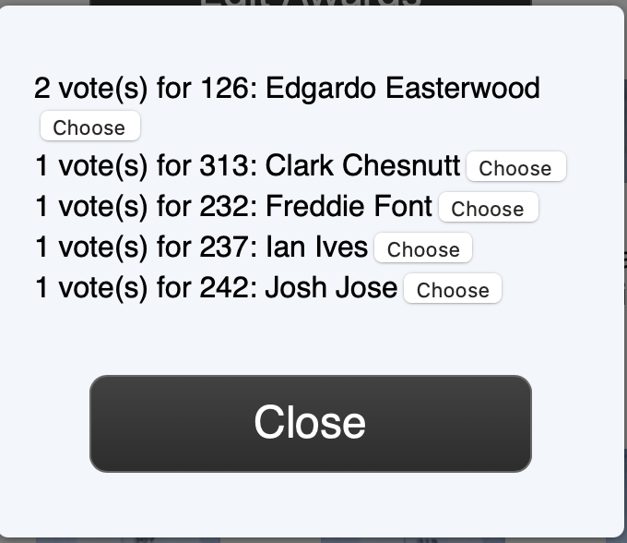

If the “Manage Ballot” button does not appear, first visit the About page to check that you are using DerbyNet v6.0, build 1180 or later. Then, visit the Set-Up page and click the “Update Schema” button. Finally, return to the Judging page.

